|  |
| --- |
| *Brought to you by:*  Dan Mendoza, Felix Ferreira, Joshua Palmer, Justin Graf, Justin McCarthy, Nathaniel Doromal and Ria Sharma  *Started 9/23/2020* |

***Table of Contents***

Real life problem to be solved

Background:

Need:

Goal:

Potential users

Key Users:

Secondary Users:

Web pages included among the website

Landing Page:

Create Account/Login:

Account Management/Home:

Messages:

Search/Recommended:

View Other's Account:

Report Account Pop-Up:

Review Users Pop-Up:

Admin Page:

Illustration of user interaction with the website

Expected user input and output for each web page

Header Menu

Landing Page

CreateAccount/Login Page

AccountManagement Page

Messages Page

Search/Recommended Page

ViewOtherUsersAccount Page

ReviewUser Modal

ReportUser Modal

Diagram #1 indicating user interaction among the web pages

Diagram #2 of Web Page Interactions

References for 3rd party software used in the code so far:

## **Real life problem to be solved**

### Background:

In General online dating websites are categorized in two types: casual dating culture and niche specific. The casual dating culture websites and applications traditionally center around getting people to meet and date quickly, such as Tinder, Bumble, and Grindr. However, this type of environment makes it difficult to identify potential partners for people who are looking for a serious relationship since the information provided is solely dependent on the user’s input, which can be altered to look believable by the user. Niche specific dating websites, on the other hand, primarily cater to a particular demographic with particular interests, such as ChristianMingle and FreeThinkerMatch. With specific demography, it is limiting the opportunity of the seeking user to find a partner that may be suited for his or her personality but does not fit a particular interest. Additionally, the popular dating website currently available either has monthly fees or has too many gimmicks that derail the purpose of the program.

### Need:

An individual person who wants to find a serious potential long-term partner deserves to use an online service that is simple, trustworthy, and focused on the goal. This online dating website must have the ability to provide feedback regarding a user's date. In addition, the website must be simple to use in a way that any legal age individuals of various backgrounds must be able to use the application with minimal operations and have streamlined design that is easy to use. The application must also use different avenues to gain revenue in a way that the users are not being penalized in finding their future partner in life.

### Goal:

The goal of this project is to provide an online dating service that is focused around a user's personality while also providing a user review service for each account. This approach resolves the shortcomings of the casual dating and niche specific dating website, and eliminates unnecessary features and functions. This website will be free for any user who wants to sign up. The target of this website is generally users who are looking to get into more serious committed relationships and do not want to spend time with bad dates.

## **Potential users**

Regardless of whether you are looking for a lifelong partner, a simple casual relationship, or even a friend, online dating applications have paved the way for interpersonal connection.

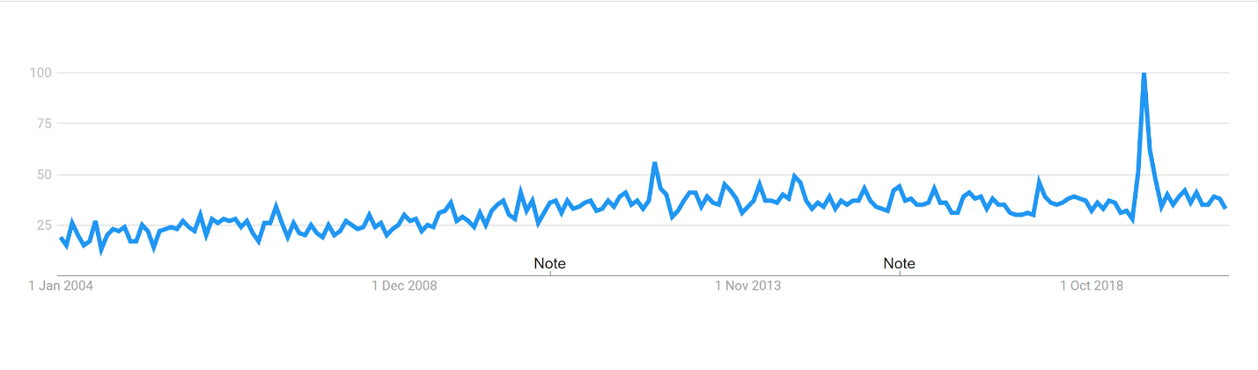

The image shows the graphical analysis of the dating application usage in the past 16 years, worldwide. The graph shows that matches on dating platforms have increased by 10% worldwide since 2020, while conversations have increased by over 20%. According to the data analysis above only half of the population ends up finding their matches, whereas, the other half, especially the users belonging to the age group of 27 and above, are usually looking for their life partners and fail to find their potential dates. Therefore, Our application targets to provide services mainly to the people who belong to this age group.

Our application classifies the users accordingly-

### Key Users:

They are critical to the continued success of the product.

* People above the age of 27 and above.
* People who are single and are looking for potential dates.
* People of all Genders.

### Secondary Users:

Users that have no accessibility needs or profile specifications for users with accessibility needs.

* People above 18 years of age.
* People who are looking for some casual dates.
* People of all Genders.
* Admins who will be in charge of managing reported accounts

## **Web pages included among the website**

There will potentially be seven webpages needed. The webpages are Landing, CreateAccount/Login, AccountManagement, ReviewUser, Messages, Search/Recommended, ViewOtherUsersAccount, and the Admin page.

### Landing Page:

The landing page is the main page of the website. This website provides access to the website features through its links while also encouraging non-users to join. The page is meant to be clean and have an attractive forestry image. At the top right the Login and Create Account buttons are if a user has not logged in yet, they both link to the CreateAccount/Login page. If a user has logged in it will have a link to their profile instead. A logout button will also then be available. The top left contains navigation and a logo. Home links back to the landing page. Search links to the search page. Recommended and Messages will be available if a user is logged, otherwise it will be greyed out and unavailable.



### Create Account/Login:

This page deals with the creation of new users and logging in of existing users. To create an account the user needs an email, this will help later with databases as a key value. We may also choose to have email based account validation, although not necessary. Once a user creates an account they will be taken to their user profile to fill in the rest of the information.

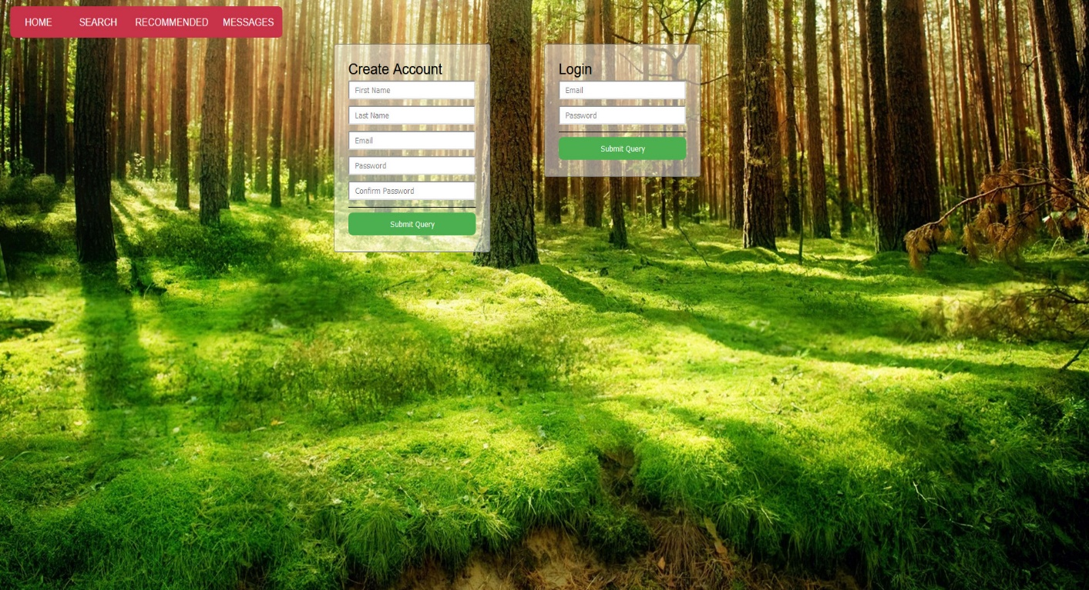

### Account Management/Home:

This is the user view of a user looking at their own profile. Elements on the left are able to be edited and saved. A user is also able to upload an image as their profile picture. Next to every user profile picture there is a PersonalityType bubble. This can either be assigned by the user from a drop down menu or if there is enough time the user can take a test. The review section is unediteable and contains reviews made by other users who have "matched" with the user.

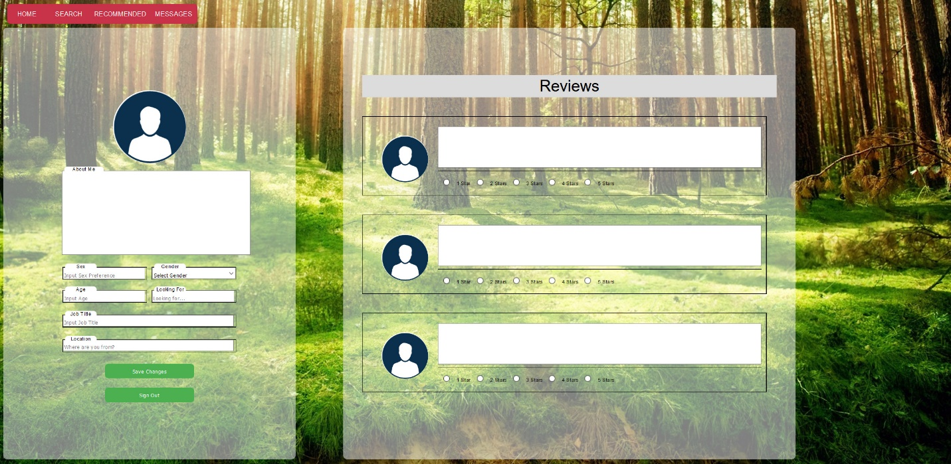

### 

### 

### 

### 

### 

### Messages:

Messaging is an integral part of the dating website. Ideally we would have a way to display if users are logged in. This can be denoted using colored bubbles under a user's profile picture or something of the like. This page will be used to message with other users to hopefully spark interest in each other. If both users decide to move forward and meet, they can choose to press a button called "Match"(not shown). If both users press the "Match" button they will be able to review each other after some time. The text will also go from match to "It's A Date!" or something similar. Below the left side of the webpage, there will be two buttons: one for saving changes to the input text fields, and another button to simply sign-out. As far as being able to edit, and delete messages sent, users will NOT be able to do either. We are trying to teach the world that what they say online, will forever be there, so think twice about saying stuff you wouldn’t want others to say to you.

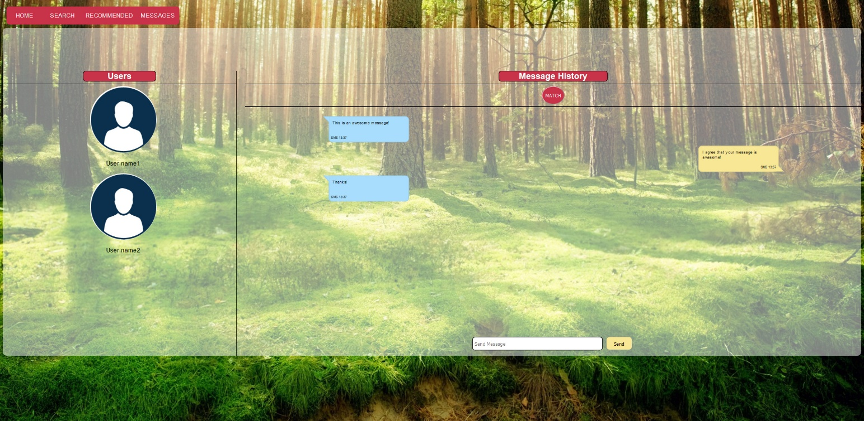

### 

### Search/Recommended:

The search page allows users to search for other users. They can search through names, personalities, job titles, etc. Only people who are online will show up(subject to change) to provide better engagement. Their rating is also displayed next to their search result, so going on good dates is crucial for people being chosen again. There is also a "Recommended" button which will search users based on personality matching types and preferences.

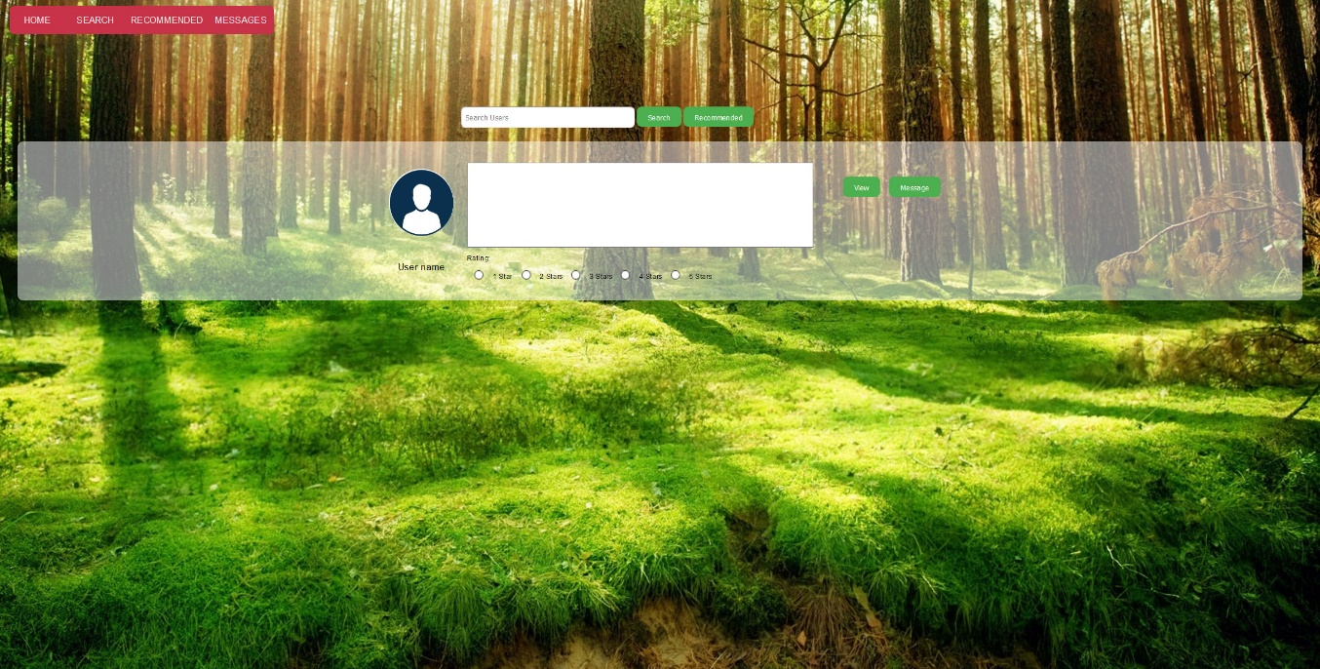

### 

### 

### 

### 

### 

### View Other's Account:

This is how others view another's profile. It is very similar to the User Management page with two differences. The visiting user cannot change the users profile information and there is an "Add Review" button. The button will add a review if the visiting user has "matched" with the user being visited. Below the user’s information, there will be a button that will allow visiting users to report that specific account.

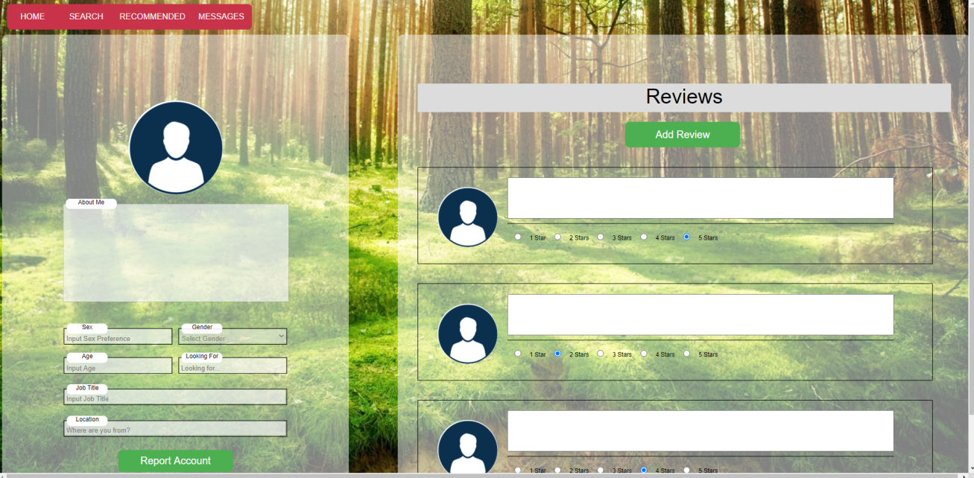

### 

### 

### 

### 

### 

### Report Account Pop-Up:

Upon clicking the button to report another user’s account on the View Other’s Account page, a pop-up modal will appear that prompts the user to input a description on why that specific account should get reported.

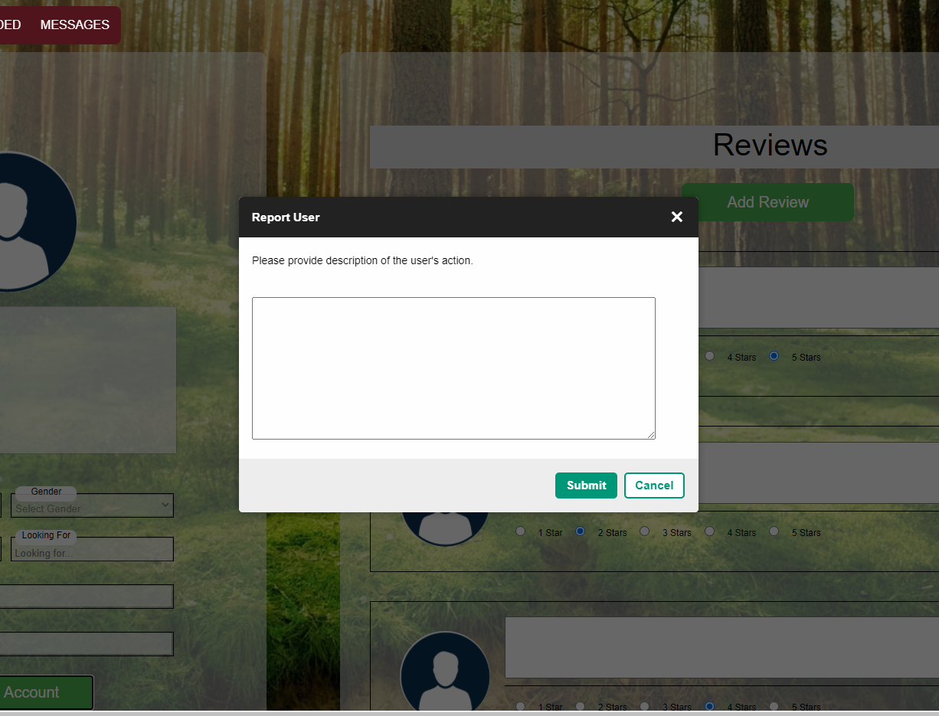

### Review Users Pop-Up:

This page lets a user leave a review. If a visiting user decides to leave a review a modal will appear when the "Add Review" button is clicked. They can give a star rating and once the "Save" button is clicked it will submit the review. Review can not be edited. Reviews may erase over time, such as one month. Below the user’s information on the right side, will be a report account button in case the user does something to merit the action such as being racist, sexist, etc. The user will only be able to review another user once, and will not be allowed to delete that review, but will be allowed to edit that review.

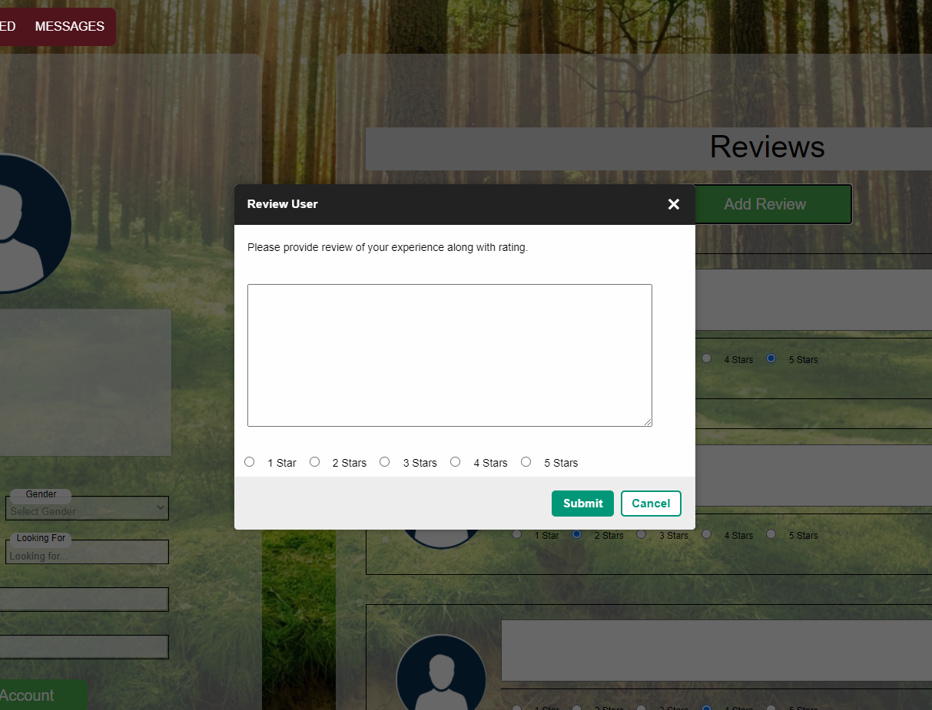

### Admin Page:

This page is strictly for the administrator. The admin will sign in as a regular user, but our backend functionality will be able to determine that the user signing in is one of them admins. Upon the admin page popping up on the screen, the admin will be greeted with a list of reported accounts. The very left side swimlane will be the user name along with their profile picture, the middle swimlane will be a description of why that specific account was reported, below the description box there will be two buttons Delete account, and ignore, and the left swimlane will provide a date the account was reported. The ignore button gets rid of that certain user’s report information from the admin page, while the delete button gets rid of the user’s account from the entire system. On the top right, there will be a sign out button to take the admin back to the landing page.

DISCLOSURE: for now, in order to get to the admin page, type in “admin” for email AND password, in the login section of the create account/login page.

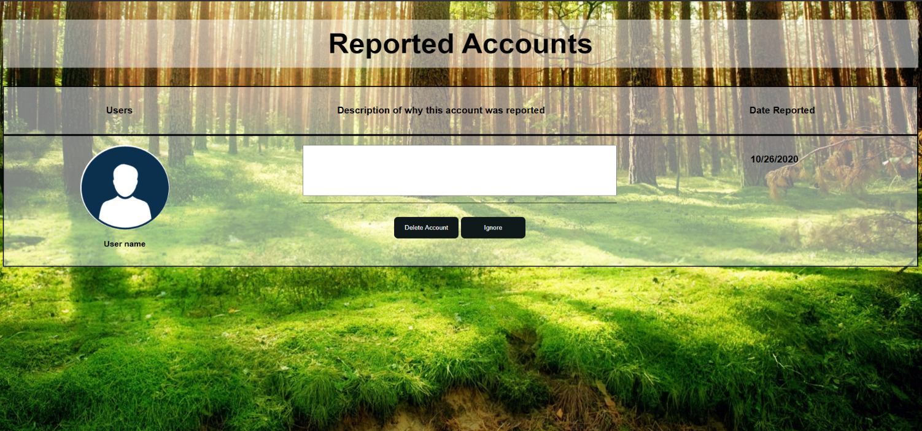

## 

## 

## **Illustration of user interaction with the website**

**Goal:** Illustrate how each potential user is going to interact with your Web site

Login/Account Creation:

All users will enter the site through the landing page.

* Current Users: Selecting the “Login” button will redirect them to the Create Account/Login page where they can enter their credentials.
* New Users: Selecting the “Create Account” or “Login” button will redirect them to the Create Account/Login page where they should enter their personal information into the Create Account section of the page.

Upon logging in, all users will be redirected to the account management page. Here they can update their public profile information including a user picture, age, location, personality type, a short about me section and more. This page will also contain a list of all the reviews other matched users have given them.

Searching Users:

When a user wants to connect with new people they can navigate to the search page. Here they will be presented with a list of other users, including a condensed version of their profile information.

The list of potential matches will be based on our personality compatibility algorithm but users can also use additional filters for age, personality type, etc. and do direct searches for things such as names or job titles.

You can learn more about a user by selecting the “view” button. This will open up their full profile page, exposing any public information including the reviews people have left for them on previous dates.

If a user finds someone they’re interested in, they can select the “message” button. This will send a request to open a conversation with them.

Chatting:

Users can communicate with each other on the Messaging page using a text messaging interphase.

After two people have gotten to know each other, either user has the option to initiate a match which the other user can accept or deny. Forming a match means that you’re ready to go on a date with this person and exposes an option on their profile to leave a date review.

Reviewing Dates:

After forming a match, users will be able to leave a review on their matches’ profile including a 1 - 5 star rating and a text description of their experience with this user. These reviews will be public to all other users on your profile page.

## **Expected user input and output for each web page**

### Header Menu

* “Account” button
  + Inputs:
    - "Account" button clicked
  + Output:
    - User is redirected to AccountManagement page.
* “Sign Out” button
  + Inputs:
    - "Sign Out" button clicked
  + Output:
    - User is logged out and redirected to Landing page.
* “Home” button
  + Inputs:
    - "Home" button clicked
  + Output:
    - User is redirected to Account management page.
* “Search” button
  + Inputs:
    - "Search" button clicked
  + Output:
    - User is redirected to Search page.
* “Recommended” button
  + Inputs:
    - "Recommended" button clicked
  + Output:
    - User is redirected to Search page with, pre-populated with search results based on matching personality types and preferences.
* “Messages” button
  + Inputs:
    - "Messages" button clicked
  + Output:
    - User is redirected to Messages page.

When the user is logged out, the Header Menu will be restricted to the Home button, the Login button and the Create Account button. The Login button and Create Account button both redirect the user to the CreateAccount/Login page.

### Landing Page

* Header Menu (logged in or logged out)

### CreateAccount/Login Page

* Header Menu (logged out)
* Create Account form
  + Inputs:
    - "First Name" text input (required)
    - "Last Name" text input (required)
    - "Email" text input (required)
    - "Confirm Email" text input (required)
    - "Password" password input (required)
    - "Confirm Password" password input (required)
    - "Submit" button (submit form)
  + Output:
    - User account is created. User is logged in and redirected to AccountManagement page.
* Login form
  + Inputs:
    - "Email" text input (required)
    - "Password" password input (required)
    - "Submit" button (submit form)
  + Output:
    - User is logged in and redirected to AccountManagement page.

### AccountManagement Page

* Header Menu (logged in)
* Account Info form
  + Inputs:
    - "About Me" text input
    - "Sex" text input
    - "Gender" text input
    - "Age" text input
    - "Looking For" text input
    - "Job Title" text input
    - "Location" text input
    - "Personality Type" drop down menu
  + Output:
    - Updates corresponding fields for external view of user's account page (viewed through "ViewOtherUsersAccount").

### Messages Page

* Header Menu (logged in)
* Other User images
  + Inputs:
    - Click Other User image
  + Output:
    - Other user is selected. Message history between user and other user is displayed.
* Send Message form
  + Inputs:
    - "Message" textbox input (required)
    - "Send" button (submit)
  + Output:
    - Text typed into "Message" textbox input field is delivered to selected other user. Sent message appears in message history.
* "Match" button
  + Inputs:
    - Click "Match" button
  + Output:
    - "Match" button is disabled. If both users click "Match" button on each other, "Match" button changes to "It's a Date!".

### Search/Recommended Page

* Header Menu (logged in)
* "Search" text input
  + Inputs:
    - Text entered in "Search" text input.
  + Output:
    - Search results (users) are displayed that match entered text in a meaningful way (name, personality type, job title, etc).
* "Recommended" button
  + Inputs:
    - Click "Recommended" button
  + Output:
    - Search results (users) are displayed matching user's personality type and other preferences.
* "View" button
  + Inputs:
    - Click "View" button
  + Outputs:
    - User is redirected to ViewOtherUserAccount page of other user.
* "Message" button
  + Inputs:
    - Click "Message" button
  + Outputs:
    - User is taken to Messages page, viewing message history with other user.

### ViewOtherUsersAccount Page

* Header Menu (logged in)
* "Add Review" button
  + Inputs:
    - Click "Add Review" button
  + Output:
    - User is shown ReviewUser modal if they have matched with the user they are viewing.

### ReviewUser Modal

* Add Review form
  + Inputs:
    - "Add Review" text input (required)
    - 5-Star rating field (required)
    - "Cancel" button (cancel form)
    - "Submit" button (submit form)
  + Output:
    - If "Close" button clicked: Add Review modal is closed without submitting review.
    - If "Save" button clicked: Add Review modal is closed, review is submitted to user's account.

### ReportUser Modal

* Report user form
  + Inputs:
    - “Add report description” text input
    - “Cancel” button (cancel form)
    - “Submit” button (submit form)
  + Output:
    - If "Cancel" button clicked: Report user modal is closed without submitting report description.
    - If "Submit" button clicked: Report user modal is closed, report is submitted to admin’s account.

## **Diagram #1 indicating user interaction among the web pages**

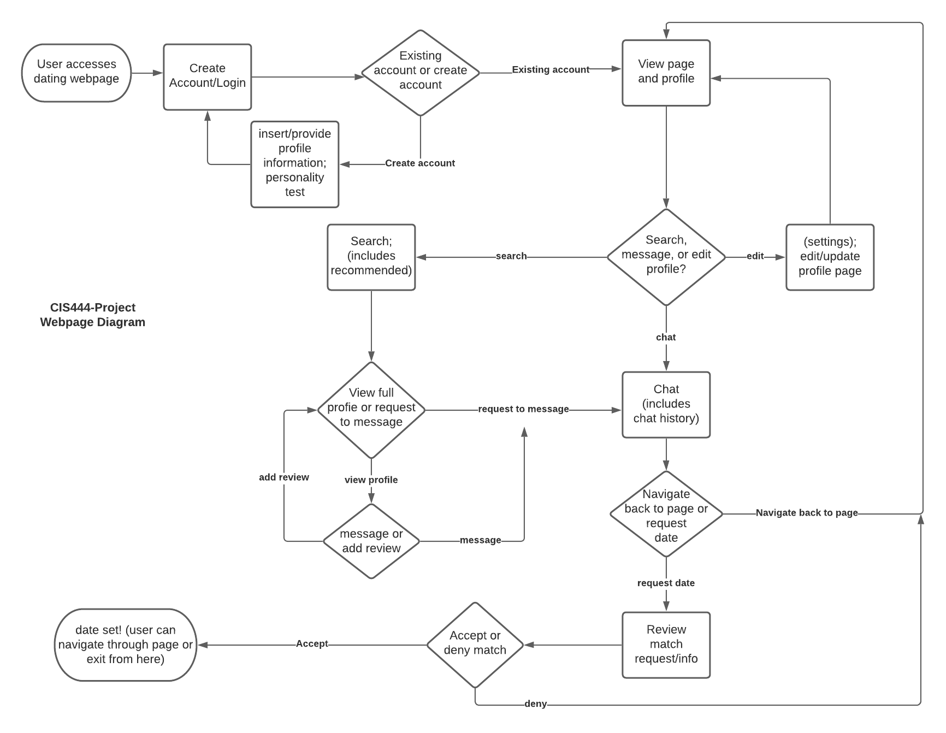

## **Diagram #2 of Web Page Interactions**

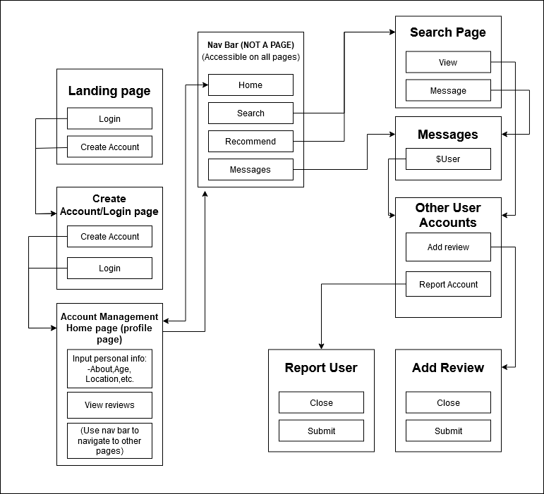

### References for 3rd party software used in the code so far:

<script src="https://code.jquery.com/jquery-1.10.2.js%22%3E

->for loading in the navbar, this way it is reuseable

</script>

<link href="https://fonts.googleapis.com/css2?family=Dancing+Script:wght@700&display=swap" rel="stylesheet">

->fancy font for landing page

<link rel="stylesheet" href="https://cdnjs.cloudflare.com/ajax/libs/font-awesome/4.7.0/css/font-awesome.min.css%22%3E

->